Purpose: The purpose of this document is to clearly outline and catalogue the primary aspects of the database component for our project. This document contains specific database design information, table structure, ER diagrams, and other key aspects related to our database.

Tables:

Our database will be composed of at least 3 primary tables. These include:

1. User Table - this will contain important information regarding users
2. ParkSpot Table - this will contain important information regarding specific parking spots
3. UserParked Table - this is an associative entity, showing when users are parked

Attributes:

See below for a quick attribute diagram, along with quick descriptions:

|  |  |
| --- | --- |
| **TABLE/ATTRIBUTE** | **DESCRIPTION/EXAMPLE** |
| User Table | Table to Store User Data |
| UserID | Primary Key, unique identifier, Auto Increment Number |
| Email | Troy Email Only - also unique value |
| Password (hashed) | Encrypted password for login purposes |
| UserTags | Tags to describe, classify users (resident, handicap, etc) |
| UserStatus | Shows if user is parked or not |
| ParkSpot Table | Table to store Parking Spot Data |
| SpotID | Primary Key, unique identifier, Auto Increment Number |
| Location | Unique Location IDs, correspond to a map |
| Rating | Calculated Attribute, Average of user ratings **optional |
| SpotTags | Tags to describe, classify Spots (visitor, staff, commuter) |
| SpotStatus | Shows if spot is taken or not |
| UserPark | Associative Table used to allow M:M relationship |
| UserID | Attribute taken from the user |
| ParkID | Attribute taken from the parking spot |
| TimeDate | System Date:Time taken when the user parks in a spot |

Relationships:

The database has two main entities, the User and the ParkSpot. For our purposes, we decided that in order to allow a user to use multiple parking spots, it was best to implement a many to many relationship between our two entities. So the relationship between user and parkspot is M:M. For this implementation, we then had to create and include our third table, the associative entity, UserPark.

Entity-Relationship Diagram:

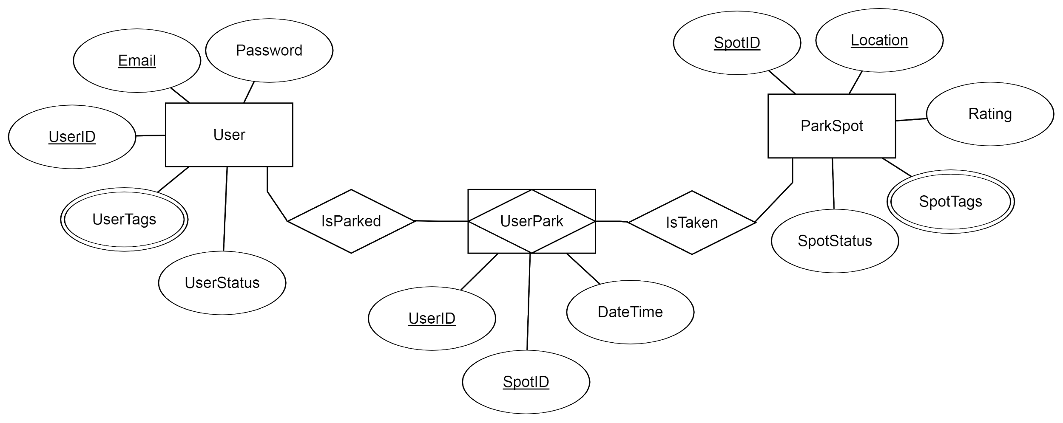

Hardware and Other Considerations:

Initially, we had planned to have a second database, or another table, which could contain a full extensive history for all users and parking spots. This would mean having user info for every parking transaction. After some deliberation, we have decided to shelve this idea due to hardware constraints. In theory, there are hundreds of parking spots and users, each accessing or being accessed dozens of time a day. Even with compression, this data would easily grow beyond our means to store. Essentially, we do not have the hardware (storage) to effectively implement this idea.